# Experiment No. 9

**AIM:** To use Google Lighthouse PWA analysis tool to set the PWA Functioning.

**THEORY:**

Lighthouse is **an open-source tool from Google that audits a web app for PWA features**. It provides a set of metrics to help guide you in building a PWA with a full application like experience for your users. Lighthouse tests if your app: Can load in offline or flaky network conditions.

**Widgets:** Each element on a screen of the Flutter app is a widget. The view of the screen completely depends upon the choice and sequence of the widgets used to build the app. And the structure of the code of an app is a tree of widgets**.**

**PWA score?**

Lighthouse measures the potential of a website using five categories: Performance, Progressive Web App (PWA), Accessibility, Best Practices, and SEO. It reviews each of these categories separately and by providing a performance score **between 0 and 100**. 0 being the lowest possible score and 100 being the best.

Lighthouse tests if your app:

* Can load in offline or flaky network conditions
* Is relatively fast
* Is served from a secure origin
* Uses certain accessibility best practices

Lighthouse is available as a Chrome extension for Chrome 52 (and later) and a command line tool.

**Running Lighthouse as a Chrome extension**

Download the Lighthouse Chrome extension from the [Chrome Web Store.](http://chrome.google.com/webstore/detail/lighthouse/blipmdconlkpinefehnmjammfjpmpbjk)

When installed it places an  icon in your taskbar.

Run Lighthouse on your application by selecting the icon and choosing **Generate report** (with your app open in the browser page).

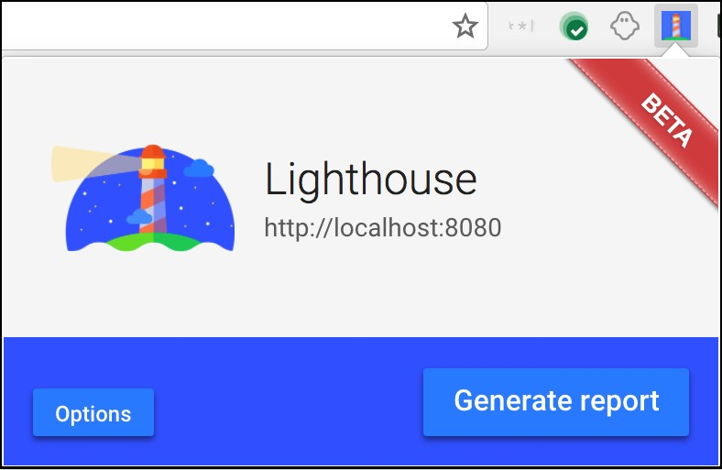

Lighthouse generates an HTML page with the results. An example page is shown below.

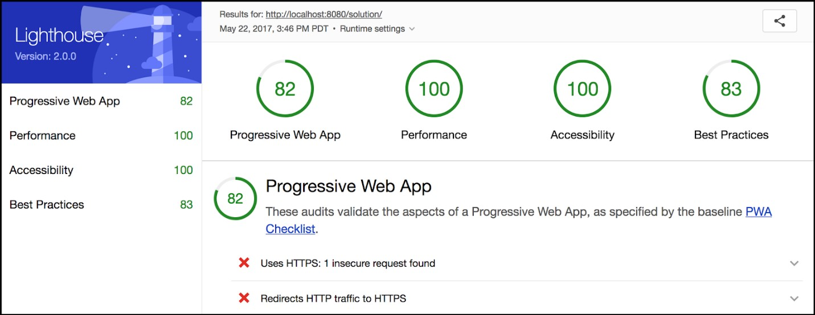

**Running Lighthouse from the command line**

If you want to run Lighthouse from the command line (for example, to integrate it with a build process) it is available as a [Node](https://nodejs.org/en/)module. You can download Node from[nodejs.org](https://nodejs.org/en/)(select the version that best suits your environment and operating system).To install Lighthouse's Node module from the command line, use the following command:

npm install -g lighthouse

This installs the tool globally. You can then run Lighthouse from the command line (where<https://airhorner.com/>is your app):

lighthouse https://airhorner.com/

You can check Lighthouse flags and options with the following command:

lighthouse –help

PWA features are advantages making them the clear choice over native and classic websites. PWAs function even when the device is offline. They make full use of modern web features including push notification, cache, and secure connections to provide rich Web based experiences.

**PWA Functioning Example:**

We test the website score: Take random website and open lighthouse and click generate PWA.

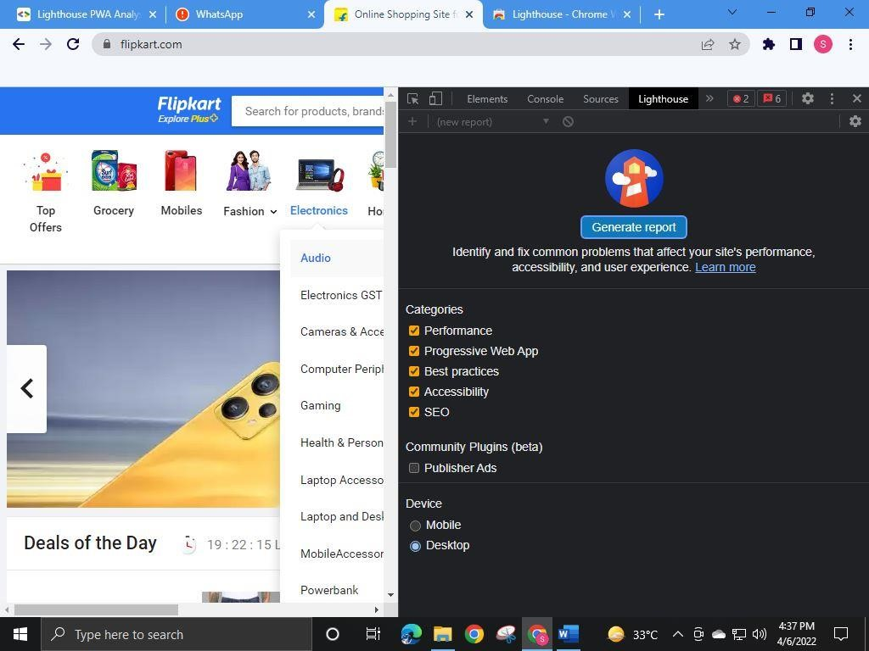

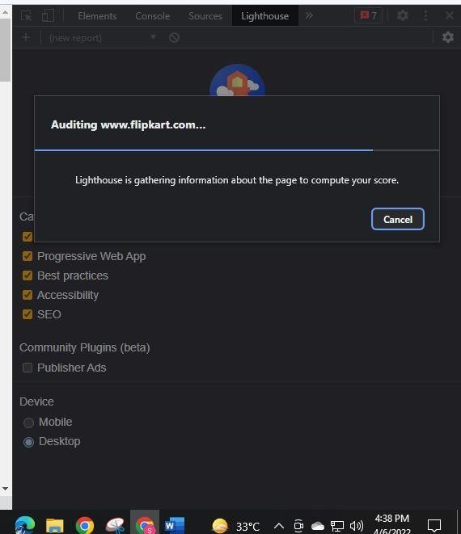

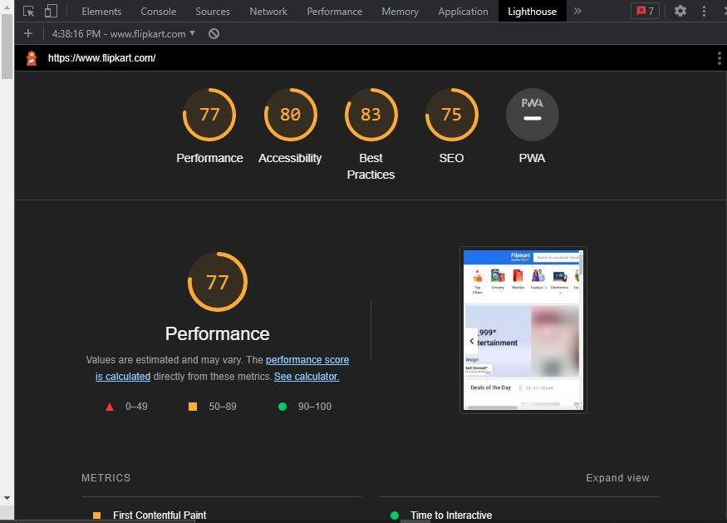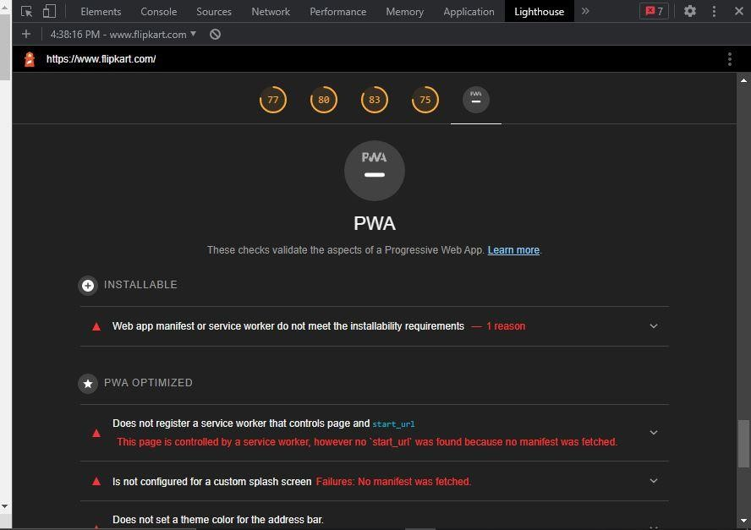

PWA features are advantages making them the clear choice over native and classic websites. PWAs function even when the device is offline. They make full use of modern web features including push notification, cache, and secure connections to provide rich Web based experiences

**CONCLUSION:** Thus, we have successfully performed a Google Lighthouse PWA analysis tool to set the PWA Functioning.